Public Notice For Sealed Bid’s:
2017 Dodge Charger Pursuit AWD

The City of Buffalo will be accepting sealed bids for the purchase of a 2017 Dodge Charger Pursuit AWD with 139,086 miles. The police interceptor is being sold “AS-IS” condition.

Sealed bids may be submitted to the city clerk at Buffalo
City Hall, 329 Dodge Street Buffalo Iowa Po box 557
No later than November 7, 2025, by 12:00 pm.

Bids will be opened November 10, 2025, at the city council meeting.
At that time the council will consider all bids and either
award the highest bidder or reject all Bids.

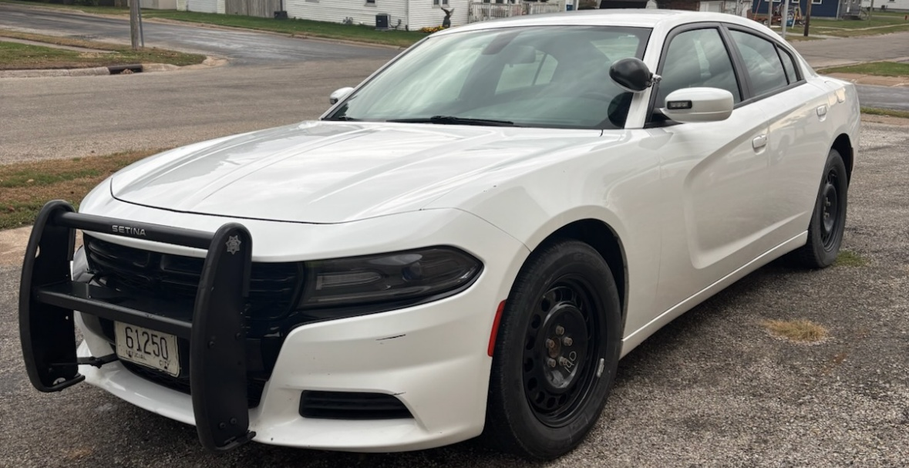
Contact Josh Ferkel for any questions at (563) 370-1092.

